Administration of Medication Policy

Hopewell School

Policy Date: | September 2024
Date Ratified by Governors: | September 2024
Next Review: | September 2025

Introduction

- The progress achieved on the Inclusion Agenda and wider changes relating to the health of children and young people mean that schools, early years settings, Headteachers and Managers in particular, are increasingly concerned about the safe administration of medicines. Whilst this policy makes a series of "good practice" recommendations and is adopted by Hopewell School it does not attempt to deal with all health issues of pupils. The Headteacher or, in his/her absence, authorised member of staff, shall have the ultimate responsibility for deciding what to do in any given situation but if possible, within the guidelines of this document.

Purpose of document

- The purpose of this policy is to put into place effective management systems and arrangements to support children and young people with medical needs in the school and to provide clear guidance for staff and parents/carers on the administration of medicines. This document must be considered in conjunction with all other relevant policies, for example, health and safety.

Roles and responsibilities

  - All staff in the school have a duty to maintain professional standards of care and to ensure that children and young people are safe. It is expected that our school will review cases individually and administer medicines in order to meet the all-round needs of the child, only where applicable i.e. if a child has to take medicine during the course of the school day as prescribed by a registered doctor or specialist. However, there is no legal duty requiring staff to administer medication or to supervise a child when taking medicines. This is a voluntary role.

- Under the Equality Act 2010, schools and settings should be making reasonable adjustments for disabled children, including those with medical needs, and are under a duty to plan strategically to increase access over time. Schools and settings should consider what reasonable adjustments they need to make to enable children with medical needs to participate fully in all areas of school life, including educational visits and sporting activities.

- The Headteacher in consultation with the Governing body, staff, parents/carers, health professionals and placing Local authorities is responsible for deciding whether the school or setting can assist a child with medical needs. The Headteacher is responsible for:

      - Implementing the policy on a daily basis;

      - ensuring that the procedures are understood and implemented;

    - ensuring appropriate training is provided;

    - making sure there is effective communication with parents/carers, children and young people, school/settings staff and all relevant health professionals concerning the pupil's health needs.

- Staff, including supply staff must always be informed of a child's medical needs where this is relevant and of any changes to their needs as and when they might arise. All staff will be informed of the designated person with responsibility for medical care.

Parents/carers

- It is the responsibility of parents/carers to:

  - inform the school of their child's medical needs;

  - provide any medication in a container clearly labelled with the following;

    - THE CHILD'S NAME
    - NAME OF MEDICINE
    - DOSE AND FREQUENCY OF MEDICATION
    - SPECIALSTORAGE ARRANGEMENTS
  - Collect and dispose of any medicines held in school at the end of each term;

  - ensure that medicines have not passed the expiry date.

Pupil information

- Parents/carers should be required to give the following information about their child's long term medical needs and to update it at the 'start of each school year':

  - Details of pupil's medical needs;

  - Medication, including any side effects;

  - Allergies;

  - Name of GP/consultants;

  - Special requirements eg. dietary needs, pre-activity precautions;

  - What to do and who to contact in an emergency;

  - Cultural and religious views regarding medical care.

Administrating medication

- It is expected that parents/carers will normally administer medication to their children at home. No medication will be administered without prior written permission from the parents/carers, including written medical authority if the medicine needs to be altered (e.g. crushing of tablets). A Request to Administer Medication Form must be completed. As stated in paragraph 3, staff are not legally required to administer medicines or to supervise a child when taking medicine. This is a voluntary role.

      - The Head teacher will decide whether any medication will be administered in school and following consultation with staff. All medicine will normally be administered during breaks and lunchtime. If, for medical reasons, medicine has to be taken at other times during the day, arrangements will be made for the medicine to be administered at other prescribed times. Pupils will be told where their medication is kept and who will administer it.

    - Any member of staff, on each occasion, giving medicine to a pupil should check:

        - Name of pupil;
        - Written instructions provided by the parents/carers or doctor;
        - Prescribed dose;
        - Expiry date.

  - Written permission from the parents/carers will be required for pupils to self-administer medicine(s). A Request to Self - Administer Medication Form must be completed.

Storage

- All medicine will be kept in a locked cabinet in the school/setting administration office. All medicine will be logged onto the school's file. Class teachers will store pupils' inhalers, which must be labelled with the pupil's name.

Records

- Staff will complete and sign a record sheet each time medication is given to a child and these will be kept in the administration office. The sheets will record the following:

  - Name of pupil;
  - Date and time of administration;
  - Who supervised the administration;
  - Witness to medication being administrated;

  - Name of medication;
  - Dosage;
  - A note of any side effects;
  - If medicine has been altered for administration (e.g. crushing tablets) and authority for doing so.

Refusing medication

- If a child refuses to take their medication, staff will not force them to do so. Parents/carers will be informed as soon as possible. Refusal to take medication will be recorded and dated on the child's record sheet. Reasons for refusal to take medications must also be recorded as well as the action then taken by the teacher. In some cases refusal to take medication may result in the pupil needing to be sent home.

Training

- Training and advice will be provided by health professions for staff involved in the administration of medicines. Training for all staff will be provided on a range of medical needs, including any resultant learning needs, as and when appropriate.

Health care plan

- Where appropriate, a personal Health Care Plan will be drawn up in consultation with the school/setting, parents/carers and health professionals. The Health Care Plan will outline the child's needs and the level of support required in school. Health Care Plans will be reviewed annually.

Intimate or invasive treatment

- This will only take place at the discretion of the Headteacher, with written permission from the parents/carers and only under exceptional circumstances. Two adults, one of the same gender as the child, must be present for the administration of such treatment. Cases will be agreed and reviewed on an individual basis. All such treatment will be recorded.

SCHOOL TRIPS

  - To ensure that as far as possible, all children have access to all activities and areas of school life, a thorough risk assessment will be undertaken to ensure the safety of all children and staff. No decision about a child with medical needs attending/not attending a school trip will be taken without prior consultation with the parents/carers.

- Residential trips and visits off site:

    - Sufficient essential medicines and appropriate Health Care Plans will be taken and controlled by the member of staff supervising the trip;

    - If it is felt that additional supervision is required during any activities eg. swimming, school/setting may request the assistance of the parent/carer.

EMERGENCY PROCEDURES

- The Headteacher will ensure that all staff are aware of the school's planned emergency procedures in the event of medical needs.

CARRYING MEDICINES

- For safety reasons children are not allowed to carry medication. All medicines must be handed to the school administration staff or the class teacher on entry to the school/setting premises.

Appendices

Appendix 1: Individual healthcare plan Appendix 2. Request to administer medication

Appendix 3.1 : Record of medicine administered to an individual child

Appendix 3.2 : Record of medicine administered to an individual child

Appendix 4: Medication Administration Record (MAR)

Appendix 5: staff training record – administration of medicines

Appendix 6: contacting emergency services

Appendix 7: model letter inviting parents to contribute to individual healthcare plan development

Appendix 8 School medication audit ( 11 pages)

Appendix 9 Procedures for supporting pupils at Hopewell with medical condition

APPENDIX 1: individual healthcare plan

Name of school/setting

Child’s name

Group/class/form

Date of birth

Child’s address

Medical diagnosis or condition

Date

Review date

Family Contact Information

Name

Phone no. (work)

(home)



(mobile)

Name

Relationship to child

Phone no. (work)

(home)

(mobile)

Clinic/Hospital Contact

Name

Phone no.

G.P.

Name

Phone no.

Who is responsible for providing support in
school

Describe medical needs and give details of child’s symptoms, triggers, signs, treatments, facilities, equipment or devices, environmental issues etc

Name of medication, dose, method of administration, when to be taken, side effects, contra-indications, administered by/self-administered with/without supervision

Daily care requirements

Specific support for the pupil’s educational, social and emotional needs

Arrangements for school visits/trips etc

Other information



Describe what constitutes an emergency, and the action to take if this occurs

Who is responsible in an emergency (state if different for off-site activities)

Plan developed with

Staff training needed/undertaken – who, what, when

Form copied to

APPENDIX 2. REQUEST TO ADMINISTER MEDICATION FORM (Please note a separate

form MUST be completed for each medicine to be administered)

Hopewell school will not give your child medicine unless you complete and sign this form, and the school or setting has a policy that the staff can administer medicine.

Date for review to be initiated by

Name of school/setting

Name of child

Date of birth

Group/class/form

Medical condition or illness

Medicine

Name/type of medicine
(as described on the container)

Expiry date

Dosage and method

Timing

Special precautions/other instructions


Are there any side effects that the
Hopewell school needs to know about?

Self-administration – y/n

Procedures to take in an emergency

NB: Medicines must be in the original container as dispensed by the pharmacy

Contact Details

Name

Daytime telephone no.

Relationship to child

Address

I understand that I must deliver the medicine personally to

[agreed member of staff]

The above information is, to the best of my knowledge, accurate at the time of writing and I give consent to Hopewell school staff administering medicine in accordance with Hopewell school policy. I will inform Hopewell school immediately, in writing, if there is any change in dosage or frequency of the medication or if the medicine is stopped.

Signature(s) ______________________ Date __________________________________

APPENDIX 3.1 : record of medicine administered to an individual child

Name of school/setting

Name of child

Date medicine provided by parent

Group/class/form

Quantity received

Name and strength of medicine

Expiry date

Quantity returned

Dose and frequency of medicine

Staff signature ______________________________

Signature of parent ______________________________

Appendix 3.2 : Record of medicine administered to an individual child

Date

Time given

Dose given

Name of member of staff

Staff initials

Witnessed by: (name of 2nd
staff member)

Staff initials

Date

Time given

Dose given

Name of member of staff

Staff initials

Witnessed by: (name of 2nd
staff member)

Staff initials

Date

Time given

Dose given

Name of member of staff

Staff initials

Witnessed by: (name of 2nd
staff member)

Staff initials

APPENDIX 4: Medication Administration Record (MAR)

Name of school/setting


Date

Child’s

name

Name of

medicine

Strength

Dosage

Quantity of medication received.


Signature of staff

Print

name

Audit

date

11

APPENDIX 5: staff training record – administration of medicines

Name of school

Name

Type of training received

Date of training completed

Training provided by

Profession and title

I confirm that [name of member of staff] has received the training detailed above and is competent to carry out any necessary treatment. I recommend that the training is updated [name of member of staff].

Trainer’s signature __________________________________

Date ___________________

I confirm that I have received the training detailed above.

Staff signature __________________________________

Date ___________________

Suggested review date

APPENDIX 6: contacting emergency services

Request an ambulance - dial 999, ask for an ambulance and be ready with the information below.

Speak clearly and slowly and be ready to repeat information if asked.

- your telephone number

- your name

- your location as follows [insert Hopewell schooladdress]

- state what the postcode is – please note that postcodes for satellite navigation systems may differ from the postal code

- provide the exact location of the patient within the school setting

- provide the name of the child and a brief description of their symptoms

- inform Ambulance Control of the best entrance to use and state that the crew will be met and taken to the patient

- put a completed copy of this form by the phone

APPENDIX 7: model letter inviting parents to contribute to individual healthcare

plan development

Dear Parent

DEVELOPING AN INDIVIDUAL HEALTHCARE PLAN FOR YOUR CHILD

Thank you for informing us of your child’s medical condition. I enclose a copy of the school’s policy for supporting pupils at school with medical conditions for your information.

A central requirement of the policy is for an individual healthcare plan to be prepared, setting out what support the each pupil needs and how this will be provided. Individual healthcare plans are developed in partnership between the school, parents, pupils, and the relevant healthcare professional who can advise on your child’s case. The aim is to ensure that we know how to support your child effectively and to provide clarity about what needs to be done, when and by whom. Although individual healthcare plans are likely to be helpful in the majority of cases, it is possible that not all children will require one. We will need to make judgements about how your child’s medical condition impacts on their ability to participate fully in school life, and the level of detail within plans will depend on the complexity of their condition and the degree of support needed.

A meeting to start the process of developing your child’s individual health care plan has been scheduled for xx/xx/xx. I hope that this is convenient for you and would be grateful if you could confirm whether you are able to attend. The meeting will involve [the following people]. Please let us know if you would like us to invite another medical practitioner, healthcare professional or specialist and provide any other evidence you would like us to consider at the meeting as soon as possible.

If you are unable to attend, it would be helpful if you could complete the attached individual healthcare plan template and return it, together with any relevant evidence, for consideration at the meeting. I [or another member of staff involved in plan development or pupil support] would be happy for you contact me [them] by email or to speak by phone if this would be helpful.

Yours sincerely

APPENDIX 8

SUPPLY OF MEDICINES

DATE:

NAME OF PERSON CONDUCTING AUDIT:
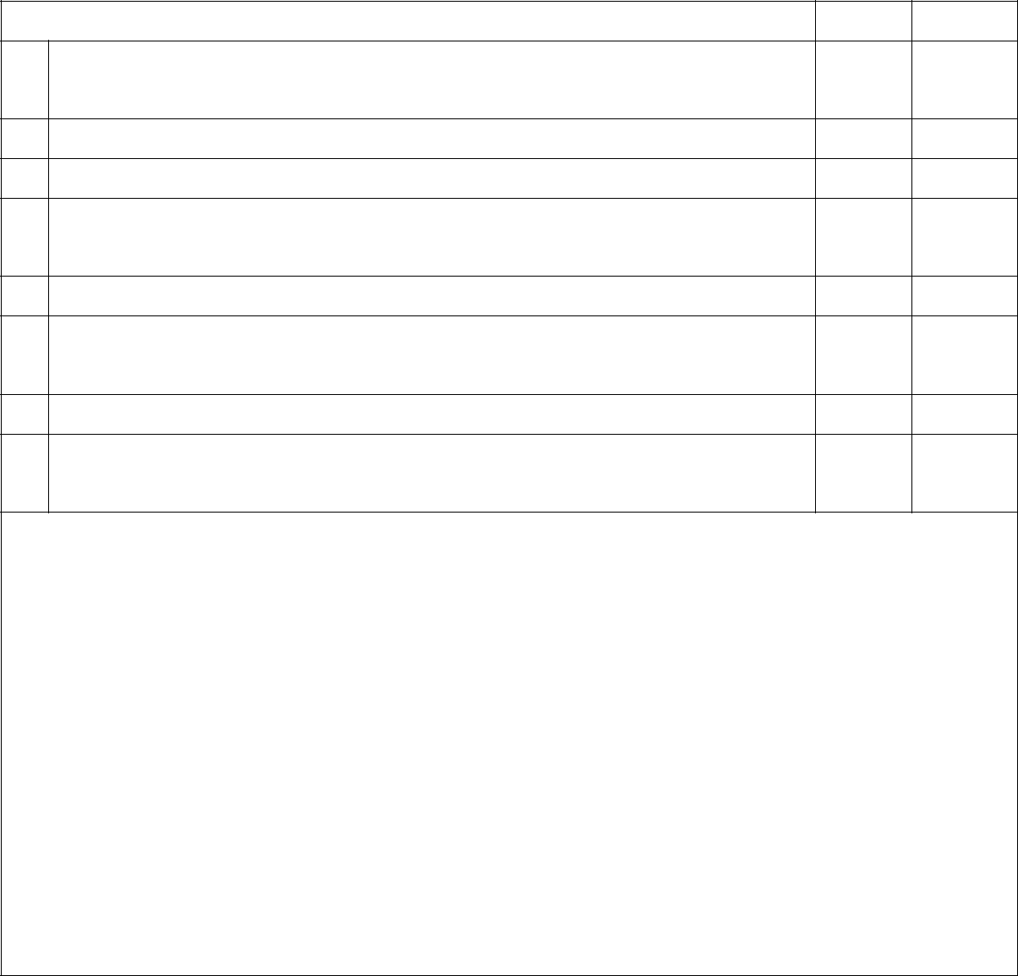

YES | NO

Are all medicines clearly and fully labelled by the
- pharmacist and in the original container?

- Are there any “as directed” labels?

- Are all medicines in date?

- Are medicines handed into school staff immediately on arrival?
- Have dose changes been authorised by the prescriber?

- Is it essential for the medicines to be taken during the school day?

- Are any medicines missing?

- Are there sufficient quantities of medicines available for the next 3 days?

Notes and actions taken:

DOCUMENTATION

YES | NO

For children with a long-term medical condition, has an IHCP been drawn

- up?

- Has a medication record sheet been set up for each child requiring administration of medicines?

- Is a parental consent letter in place for each child requiring administration of medicines?

- Do parents provide details of any changes to prescriptions or the support required?

- Does this correlate with the information provided by the prescriber?

- Is a written record made when a medicine is administered?

- Are risk assessments and plans drawn up for medicines needed on school trips, sporting activities, off site visits etc?

Notes and actions taken:

STORAGE

YES | NO

Are all medicines stored safely and appropriately?
1.

- 2. Is key security appropriate?

- 3. Are appropriate quantities of medicines held?

- 4. Are emergency medicines easily accessible e.g. asthma inhalers and adrenaline pens?

- 5. If medicines require fridge storage, are they stored safely in an airtight container, clearly labelled

- and separated from food?

- 6. Are Controlled Drugs stored securely?

- 7. What is the temperature of the medicines room? (it should be less than 25 °C)

Notes and actions taken:

BASIC HYGIENE AND HOUSEKEEPING

YES | NO

- Are hands washed prior to administration of medicines?

- Are gloves worn when creams are administered?

- Are storage cupboards clean, tidy and secure?

- Are expiry dates of medicines checked?

- Are containers dated on opening, if appropriate?

- Where necessary, is stock rotated to avoid it going out of date?

Notes and actions taken:

ADMINISTRATION

YES | NO

  - Is PRN (when required) medication given according to a written protocol in the IHCP?

- Is medication given at appropriate times?

- Have any medications been missed? (state details below)

- 4Does any child need to take medication out with them e.g. for trips, sporting activities etc?

- Is there an appropriate system in place for this?

- Is there an in/out log for medication for day trips, holidays etc?

- Are any refusals to take medication recorded and reported back to the parents on the same day?

- Is there any evidence of medicines being disguised in food or drink?

- Are liquid doses measured accurately?

- Does the number of tablets remaining agree with the medication records

Notes and actions taken:

RECORDING OF MEDICINES

YES | NO

- Is there an audit trail of (signed in/out) medicines in place? (i.e.medicines received, administered and returned to parents)

- Are all medications signed for when they are administered?

- Are PRN (when required) medications recorded appropriately?

- Are dose changes/amendments to medication accurately recorded on the medication record

Notes and actions taken:

DISPOSAL OF MEDICINES

YES | NO

- Is there a record of all medication returned to parents?

- Do parents collect unused medicines at the end of summer term?

- Are uncollected medicines taken to the pharmacy at the end of the term?

- Are sharps boxes used for disposal of needles?

Notes and actions taken:

EMERGENCY PROCEDURES
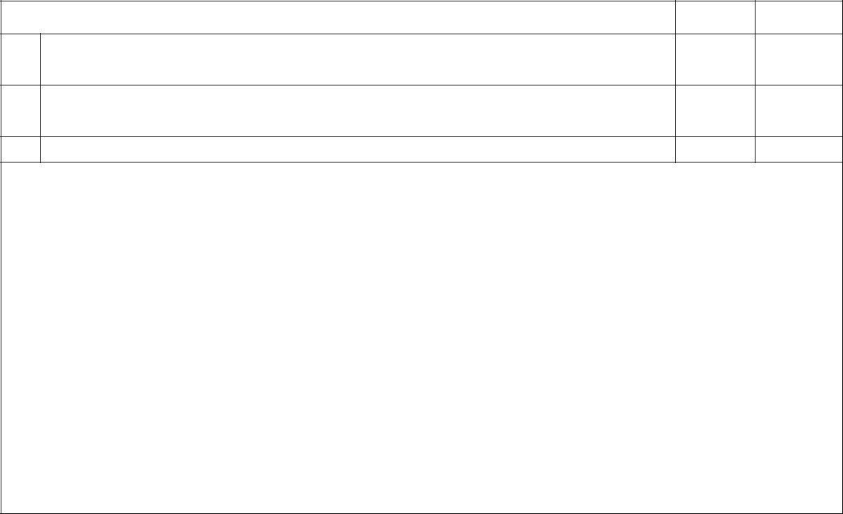

YES | NO

Is there a policy in place for dealing with emergencies?
1.

- Are staff aware of who is responsible for carrying out emergency procedures?

- Are staff aware of the circumstances in which to call an ambulance?

Notes and actions taken:

NON-PRESCRIBED MEDICINES

YES | NO

Does the school’s policy allow the administration of non-prescribed
- medicines?

- 2. If yes, has specific prior written permission been given from the parents for any non-prescribed

- medicine to be administered?

- 3. Is there certification in writing from the parents that the medicine has been administered to the

- child in the past without adverse effect? (Best Practice)

- 4. If children are receiving non-prescribed medicines, has the possibility of interactions with other

Notes and actions taken:

SELF-ADMINISTRATION OF MEDICINES

 |  | YES | NO
1. | Are children encouraged and supported to take responsibility for their
 | own medicines where appropriate?
2. | Are risk assessments carried out for children who self-administer?
3. | Have the parents and/or health professionals been involved in the
 | decision?
4. | Is supervision of medicines administration required by staff for any
 | children?
5. | Do any children carry their own medicines with them?
6. | Has this been risk assessed and monitored?
7. | Has a parental consent form been completed?
8. | Has a risk assessment for self-administration of Controlled Drugs been
 | undertaken?
9. | Are these Controlled Drugs kept in safe custody with the child being
 | able to access them as appropriate?
10. | Are storage arrangements appropriate for children self-administering
 | medicines?

Notes and actions taken:

ADVICE AND TRAINING

YES | NO

Have all relevant staff been trained to administer medicines?
1.

- 2. Is all staff training documented?

- Has a healthcare professional been consulted for the training of specialist tasks e.g. adrenaline
pens, insulin etc

- Have staff competencies been assessed?

- Have staff received a refresher medication training course after 2 years to update them on latest
procedures and guidelines?

- Are all staff aware of their responsibilities?

- 7. Do staff know who to contact for advice and support?

- 8. Have all medication errors and incidents been documented?

- Have these incidents been audited and used as an educational tool to improve practice and
prevent recurrence

Notes and actions taken:

Appendix 9

Procedures for supporting pupils at Hopewell with medical condition

A PARENT INFORMS THE SCHOOL THAT THEIR CHILD REQUIRES SUPPORT WITH

MEDICAL CONDITION


 |  | The medical condition is
The medical condition is |  | The medical condition is
long term and requires |  | short term and requires
an IHCP |  | prescribed medication

The SENDCo works with
The SENDCo works with |  | The parent/carer
the family to ensure that |  | completes a Hopewell
an IHCP is in place and |  | request to administer
the relevant staff are |  | medication form,
trained to deliver it |  | authorising staff to
 |  | oversee the
 |  | administration of the
 |  | prescribed medication


- The IHCP is kept in the pupil’s personal file in the school office.

- Details of the child (inc Photo) is added to the medical needs list by the SENDCo

- Designated members of staff/medical first aider follow the instructions of the care plan

The medical condition is short term and requires non-prescribed medication


The school will oversee the administration of the non-prescribed medication only with parents written consent

- The prescribed medication is kept in the first aid room

- The SENDCo/designated medication lead oversees which medicines needs to be administered and carries out an audit every half term

- When the medicine is administered it is recorded in a book (also kept in the medical room)

